// B00060572 David Kelly 27/9/2012

Worksheet 1

Part (a)

1. Explain following terms:

Source Code - Is high level programming code normally written in a human language and used in…. Java, C++, Pascal, Perl.

Machine Code - Is the only format of code the machine truly understands and is represented in Binary.

High Level Language - Is human language understood by the program and can be converted in to machine code.

Java Byte Code - Is the code the compiler translates the High level language in to so that it can be interpreted by the JVM.

Software - Is the term given to the programmes and operating systems that make a computer function.

Algorithm - Is a series of steps involved to carry out a task that solves a particular problem.

Compiler - Is a piece of software that translates high level language in to machine code and Java byte code.

1. A Java compiler translates HLL in to Java byte code so that it can run on whatever operating system the JVM is installed for.

A conventional Compiler translates HLL in to conventional Machine Code so as that the program can run on the OS it was intended for.

1. The JVM is a piece of software that acts like a computer that runs java. It sits on top of the OS and allows java programs to run on any OS with JVM installed
2. Platform independence is a piece of software that can run irrelevant of the OS it is on
3. .Java files are written in high level language and are saves as they are written.  
   .class files are written in machine code and are a result of when the compiler translates the HLL.
4. Indention and comments are important in program code because it is often difficult to find the Syntax error made if the program has a large script.
5. 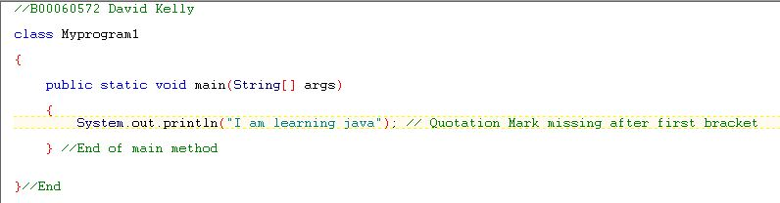
6. 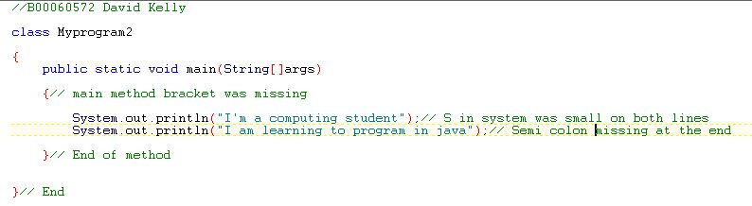
7. 